Phishing Indicators Report
After analyzing various samples of phishing email, several clear indicators I was able to find out these threat intent. These indicators demonstrate common techniques used by attackers to deceive recipients and gain unauthorized access to personal or financial information.
- Suspicious Sender Address
This includes Minor misspellings, these emails look exactly like the original company but they contain minor spelling differences 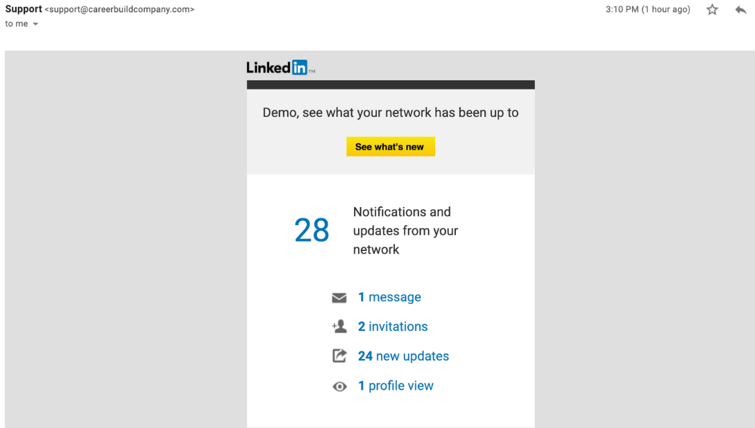
This is a sample to a Phishing email id we look at it in the first glance we might find nothing suspicious but on close observations we see that the domain of LINKDIN is “linkdin.tm” which is a fake address.
- Header Discrepancies
Email header analysis revealed mismatched “From” and “Return-Path” fields.
3. Malicious or Suspicious Links
- Hyperlinks in the email redirected to unrelated or suspicious domains.
- The visible link text did not match the actual URL destination.
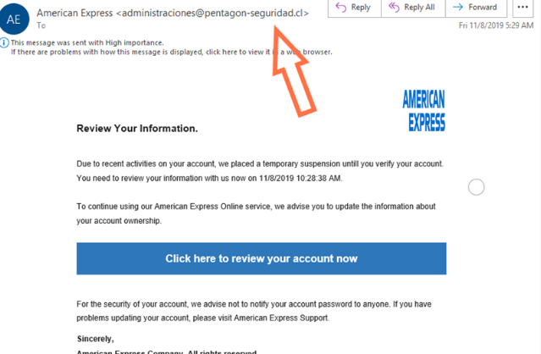
4.Urgent or Threatening Language
- The message attempted to create panic by claiming immediate action was required (e.g., account closure, security breach, urgent action needed ).
- This urgency is a common tactic used to pressure victims into responding quickly and get trapped in the act of threat . 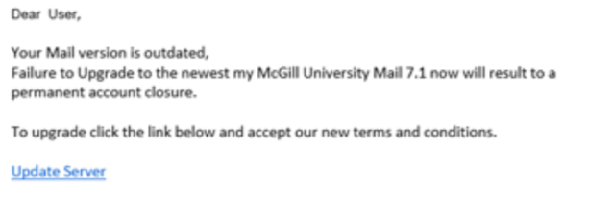
6. Spelling and Grammar Errors
- Multiple spelling mistakes and grammatical errors were present.
- Companies use a format to write their names ie ; ”PayPal” but as the example shows that there are multiple versions of “PayPal” .
- 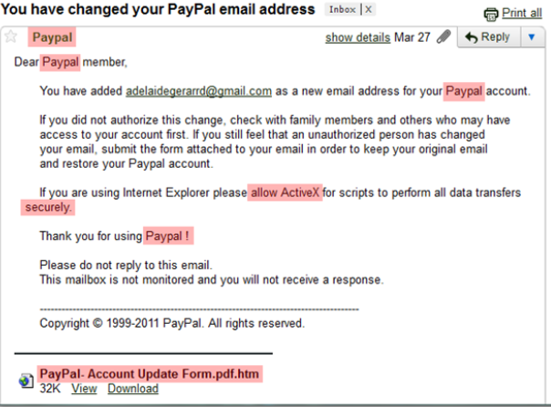
7. Inconsistent Branding and Formatting
- The email’s layout, logo quality, and formatting did not match the official style of the organization it claimed to represent.

REPORT BY
Mahi Saini

